**EXPLORING THE DATASETS FROM CHICAGO USING SQL QUERIES**

Loading the data in to the IBM DB2 database.

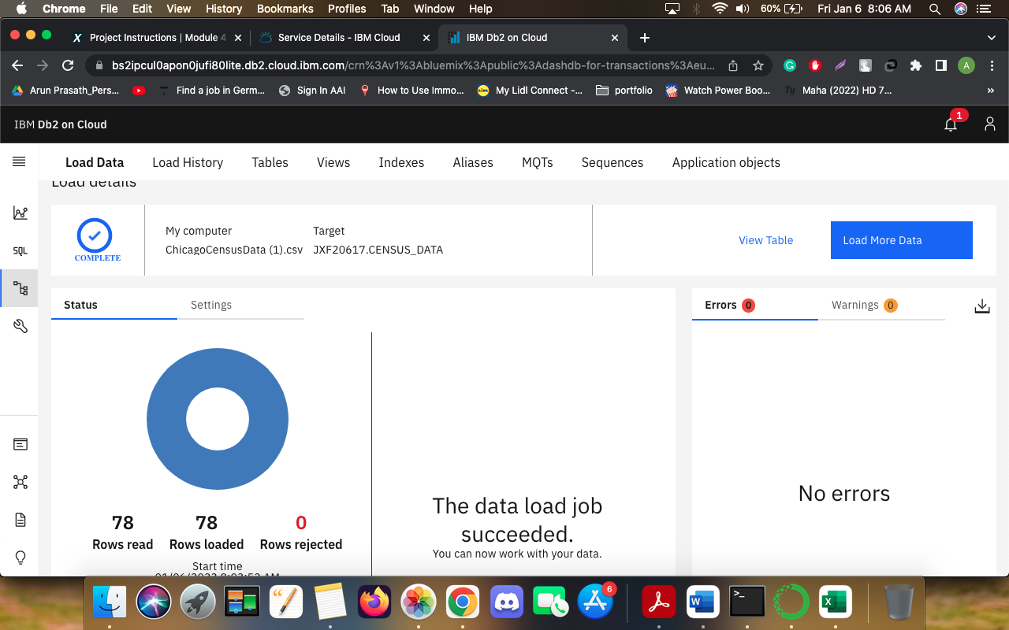

The picture below shows all the tables loaded in to the database.

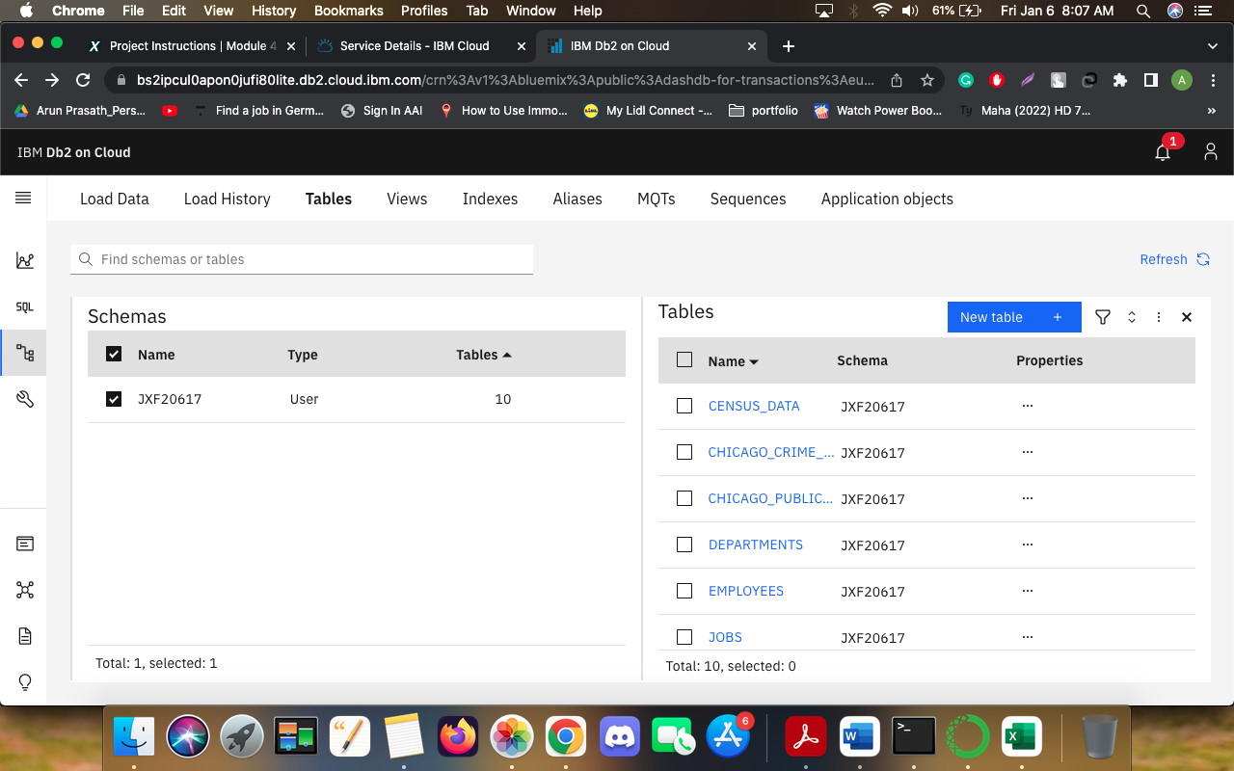

### **SQL QUERIES:**

### **Problem 1**

Find the total number of crimes recorded in the CRIME table.  
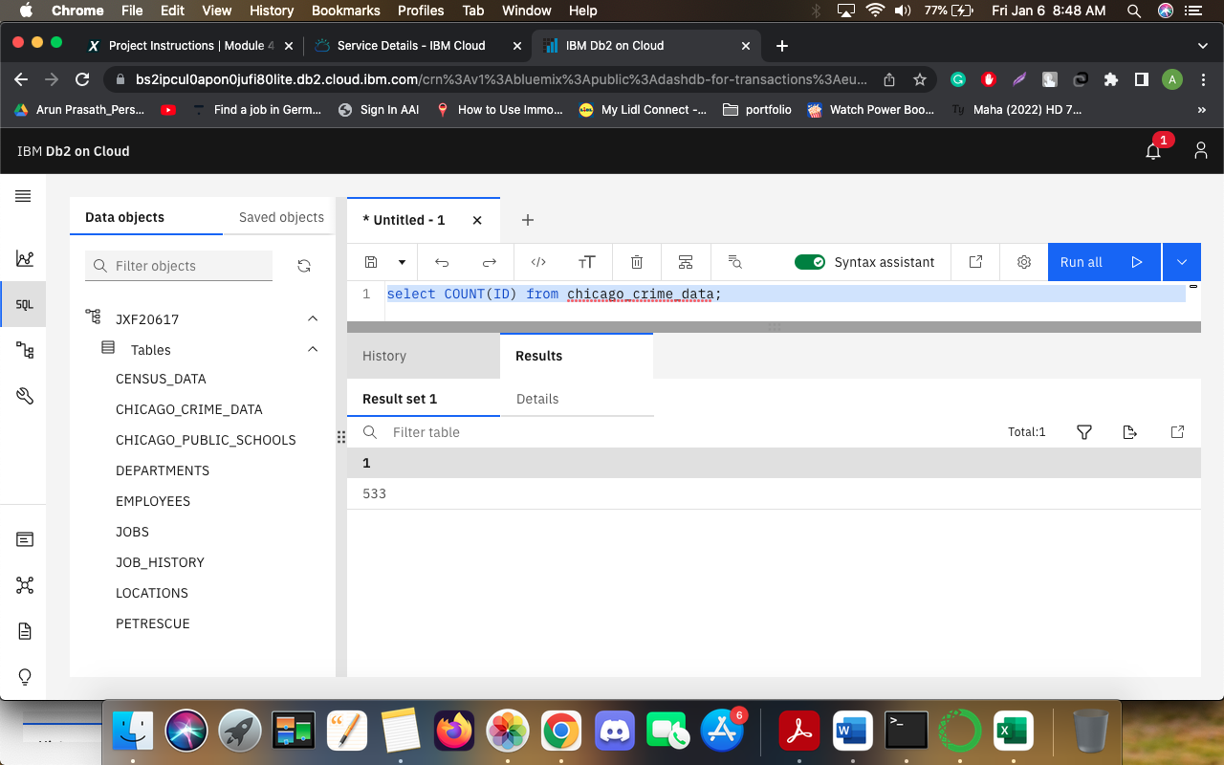

### **Problem 2**

Retrieve first 10 rows from the CRIME table.  
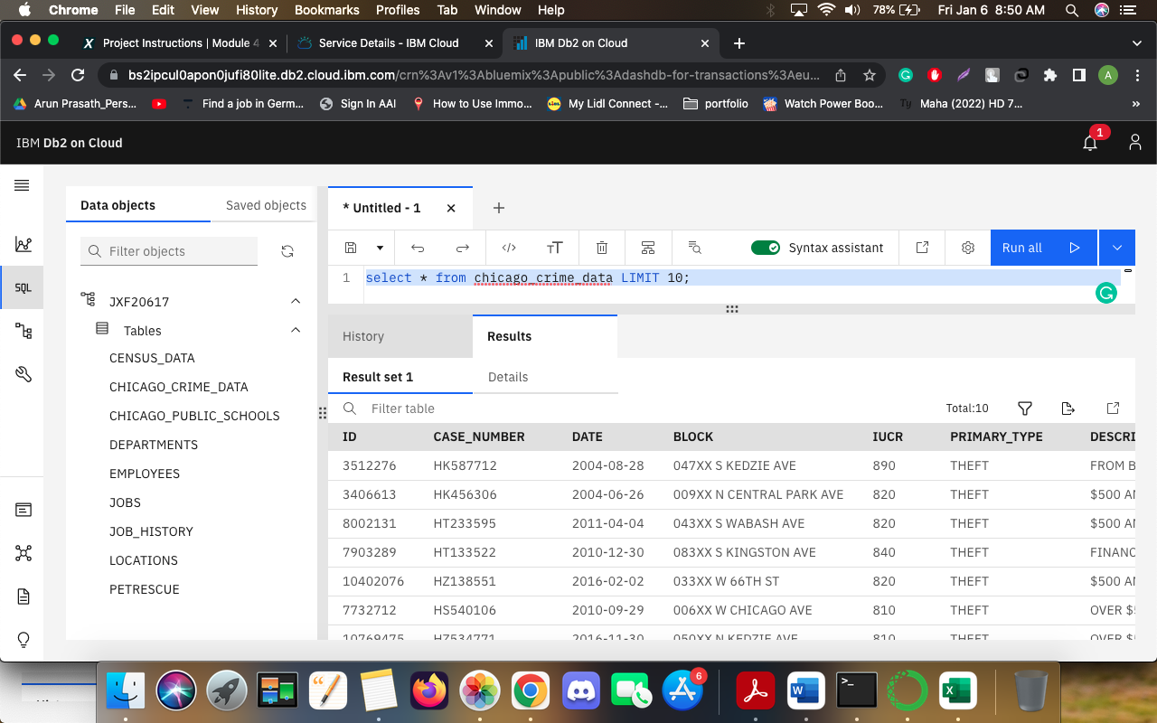

### **Problem 3**

How many crimes involve an arrest?  
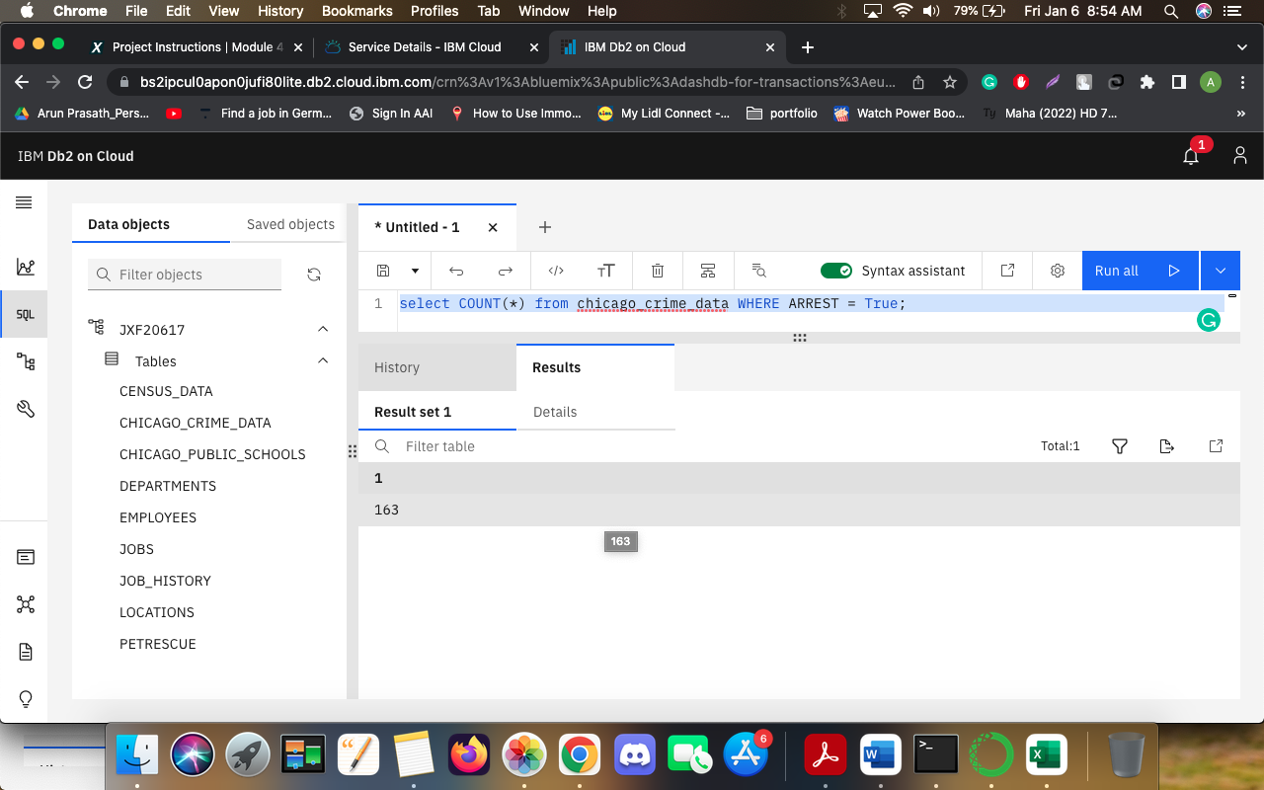

### **Problem 4**

Which unique types of crimes have been recorded at GAS STATION locations?

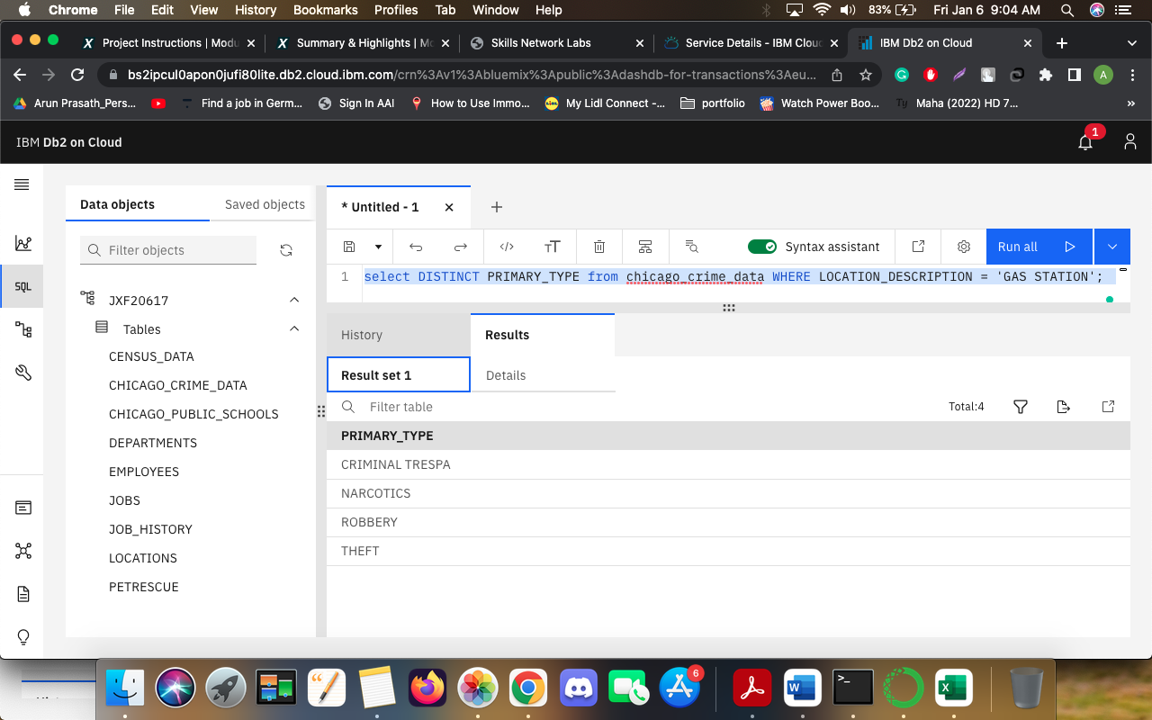

### **Problem 5**

In the CENUS_DATA table list all Community Areas whose names start with the letter ‘B’.  
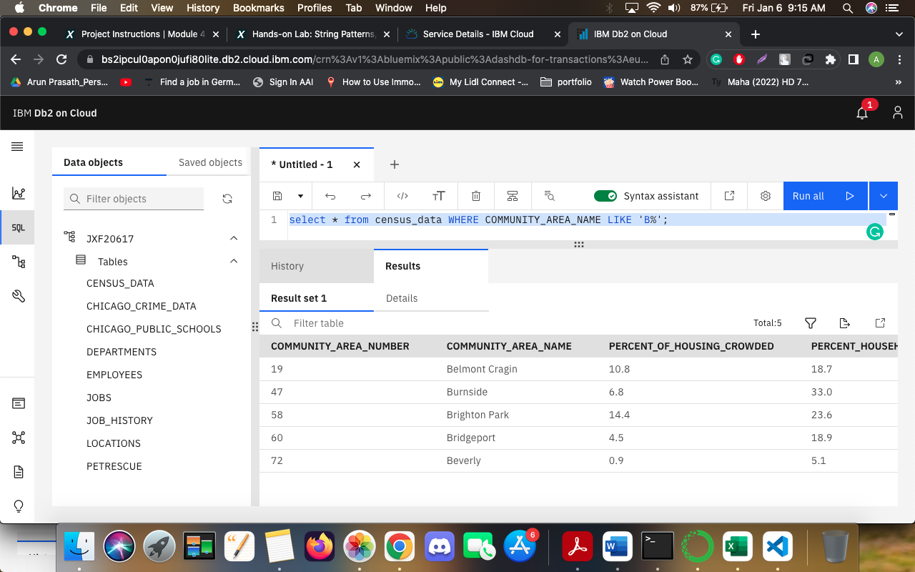

### **Problem 6**

Which schools in Community Areas 10 to 15 are healthy school certified?  
  
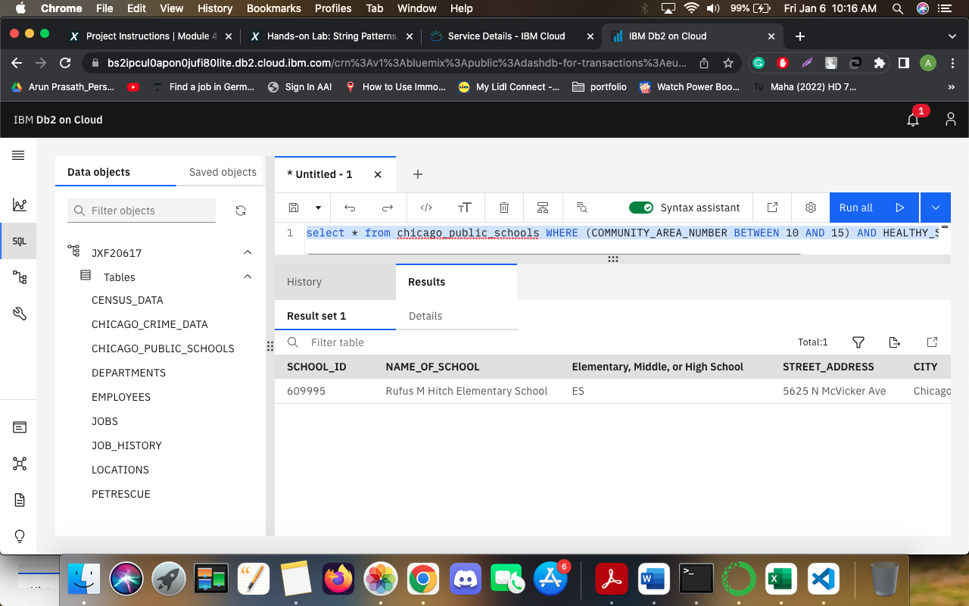

### **Problem 7**

What is the average school Safety Score?  
